Given the root of a binary tree with unique values and the values of two different nodes of the tree x and y, return true *if the nodes corresponding to the values* x *and* y *in the tree are* ***cousins****, or* false *otherwise.*

Two nodes of a binary tree are **cousins** if they have the same depth with different parents.

Note that in a binary tree, the root node is at the depth 0, and children of each depth k node are at the depth k + 1.

**Example 1:**

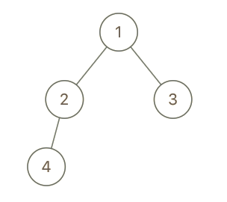

Input: root = [1,2,3,4], x = 4, y = 3  
Output: false

**Example 2:**

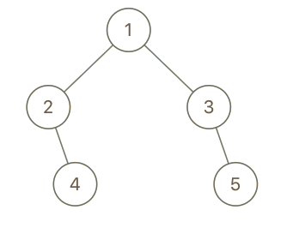

Input: root = [1,2,3,null,4,null,5], x = 5, y = 4  
Output: true

**Example 3:**

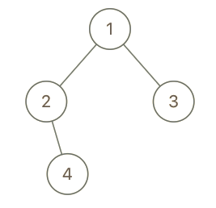

Input: root = [1,2,3,null,4], x = 2, y = 3  
Output: false

**Constraints:**

* The number of nodes in the tree is in the range [2, 100].
* 1 <= Node.val <= 100
* Each node has a **unique** value.
* x != y
* x and y are exist in the tree.